**一、字彙選擇-選出聽到的單字**：

( )1.(A)uncle

(B) grandmother

(C) daughter

(D) cousin

( )2.(A) leader

(B) thirty

(C) group

(D) cellphone

( )3.(A) video

(B) music

(C) monkey

(D) someone

( )4.(A) party

(B) watch

(C) rabbit

(D) game

二、聽力(基本問答)-根據聽到的內容，選出合適的回應：

( )5.(A)I’m five.

(B) I’m fine.

(C) He’s happy here.

( )6.(A)She’s from Canada.

(B) She is in the USA.

(C) He’s from Taiwan.

( )7.(A)He’s ten.

(B) Yes, he’s twelve.

(C) He’s a student.

( )8.(A)Yes, it is.

(B) Yes, they are.

(C) No, you are not.

三、聽力(辨識句意)-根據聽到的內容，選出正確的圖片代碼：

( )9.(A)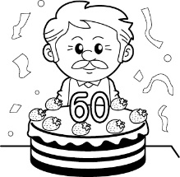　(B) 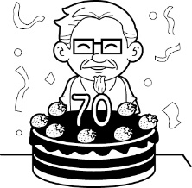　(C) 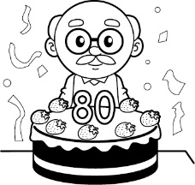

( )10.(A)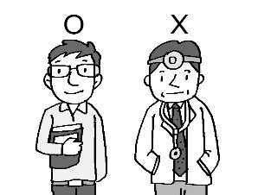　(B) 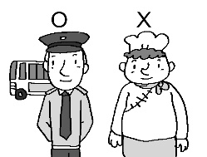　(C) 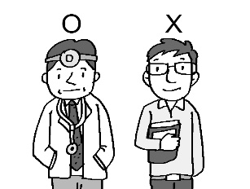

( )11.(A)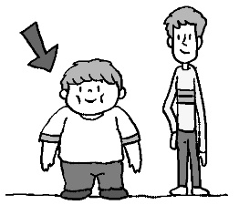　(B) 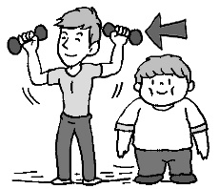　(C) 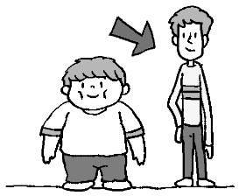

( )12.(A)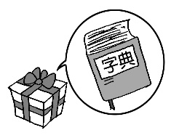　(B) 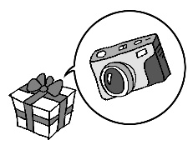　(C) 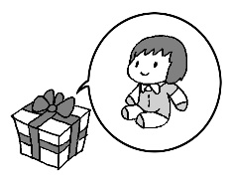

四、聽力(言談理解)-根據聽到的對話內容與問題，選出正確的答案：

( )13.(A) Yes, it is.

(B) No, it isn’t.

(C) It’s afternoon.

( )14.(A) Kevin.

(B) Joseph.

(C) Eric.

五、聽力(短文聽解)-根據聽到的短文，選出符合的圖片代碼：

( )15.(A) 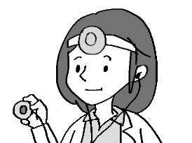　(B) 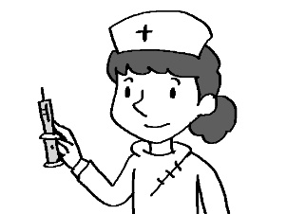　(C) 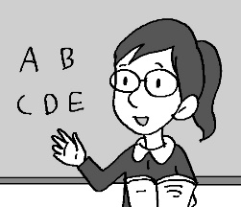

六、對話與文法選擇

( )16.Mary: Nancy: He’s nice and helpful.

1. Where’s the cat from?
2. What’s the boy?
3. Are your new classmates nice?
4. How’s your new English teacher?

( )17.That father is Bill, my math teacher.

1. a girl’s
2. boy’s
3. girl
4. boys’

( )18.Peter: Are you not an elementary school student?

1. No, I am.
2. No, I am a student.
3. Yes, I am not.
4. Yes, I am.

( )19. the dog that bites people yours? You should keep it at home.

1. Does
2. Do
3. Is
4. Are

( )20.Tina: Where is Mary ?

Nancy: She is from the UK.

1. on
2. from
3. at
4. in

( )21.My son is year old.

1. one
2. six
3. ten
4. twenty-two

( )22.Kevin: your name?

May: May.

1. How’s
2. Where’s
3. What’s
4. Who’s

( )23.Amy: What are these?

Bill: These .

1. are cats
2. cats are cute
3. is a cat
4. cat is cute

( )24.My cousin is a kind beautiful girl.

1. or
2. X
3. and
4. but

( )25.Don’t in the MRT stations.

1. eat or drink
2. eating or drinking
3. eats or drinks
4. please eat or drink

( )26.Look! The student in the classroom.

1. runs
2. is run
3. run
4. is running

( )27.Jack: is it?

Coco: It’s 7: 30 a.m. now.

1. How old
2. What day
3. What time
4. How tall

( )28.Jeff: Are there any cards on the desk?

Lucy: Yes, .

1. they are
2. there are
3. there are not any
4. there is

七、閱讀測驗

|  |
| --- |
| It is Sunday afternoon. Tom and his friends, Jack and Bill, are playing basketball in the park. Tom’s mother and his sister, Sue, are singing and dancing with many kids there.  But Tom’s father is not in the park. He is at home. He is watching a good movie on TV. Their dog, Lucky, is playing outside. |

( )29.Who is Bill?

1. Tom’s friend.
2. Tom’s brother.
3. Sue’ friend.
4. Tom’s dog.

( )30.What are Sue and her mother doing in the park?

1. They are reading and writing.
2. They are singing and dancing.
3. They are watching a good movie.
4. They are playing basketball.

**108.3.16英語科答案**

|  |  |  |  |  |  |  |  |  |  |
| --- | --- | --- | --- | --- | --- | --- | --- | --- | --- |
| **1** | **2** | **3** | **4** | **5** | **6** | **7** | **8** | **9** | **10** |
| **C** | **D** | **B** | **D** | **B** | **A** | **A** | **B** | **B** | **C** |
| **11** | **12** | **13** | **14** | **15** | **16** | **17** | **18** | **19** | **20** |
| **B** | **A** | **B** | **A** | **B** | **D** | **B** | **D** | **C** | **B** |
| **21** | **22** | **23** | **24** | **25** | **26** | **27** | **28** | **29** | **30** |
| **A** | **C** | **A** | **C** | **A** | **D** | **C** | **B** | **A** | **B** |