選擇題：(20題，每題2分，共40分)
一、字彙、文法及對話選擇：
1.（ ）I want two for breakfast.
(A) sandwich (B) apple (C) rice (D) hamburgers
2.（ ）Seven is my number.
(A) young (B) classmate (C) squid (D)lucky
3.（ ）Peter: What you do every day?
John: I watch TV programs at home every day.
(A) do (B) are (C) have (D) is
4.（ ）Sarah: does your baby go to bed?
Will: About ten o’clock. (A) How soon (B)What day (C)How old (D) What time
5.（ ）Kelly: is Miss Lin?
Danny: She is my Chinese teacher. (A) How (B) Who (C) Where (D) What
6.（ ）Jane: Can Tom speak English?
Eric: Yes, speak English. (A) Tom can (B) he is (C) he can (D) he can’t
7.（ ）My son usually his homework at eight o'clock.
(A)goes (B)gets (C)does (D) writes
8.（ ） is hot. (A) Winter (B) Summer (C) Fall (D) Spring
9.（ ）John is .
(A) kind teacher (B) teacher kind (C) a kind teacher (D) kind teachers
10.（ ）Today is Mother’s birthday. I will buy my mother watch as a birthday gift.
(A) a (B) an (C) three (D) two
11.（ ）A: How old is Linda?
B: She is .
(A) a twelve-year-old girl (B) a eight years old (C) ten year old (D)one years old.
12.（ ）My students English in the classroom now.
(A) is studying (B) study (C) studies (D) are studying
13.（ ）Linda: are the pencils?
Coco: They are ten dollars. (A) How many (B) How far (C) How often (D) How much
14.（ ）Please your book. (A) open (B) not open (C) opening (D) opens
二、克漏字選擇：
Amanda: What's that?
David: I don't know. Hmm, oh, it's a small box.
Amanda: Let's open it. Maybe there is a lot of money.
David: Hey, wait, may be it's a bomb! （15）
Amanda: So what can we do now?
David: Look, it's time for class. We must report to our teacher right now.
Amanda: （16） It's safer to do so.

15.（ ）(A) Go on! (B) Don't stop! (C) Don't move. (D) Hurry up!
16.（ ）(A) That's a good idea. (B) No way. (C) Come on in. (D) Say Cheese.

背面尚有試題

三、閱讀測驗：
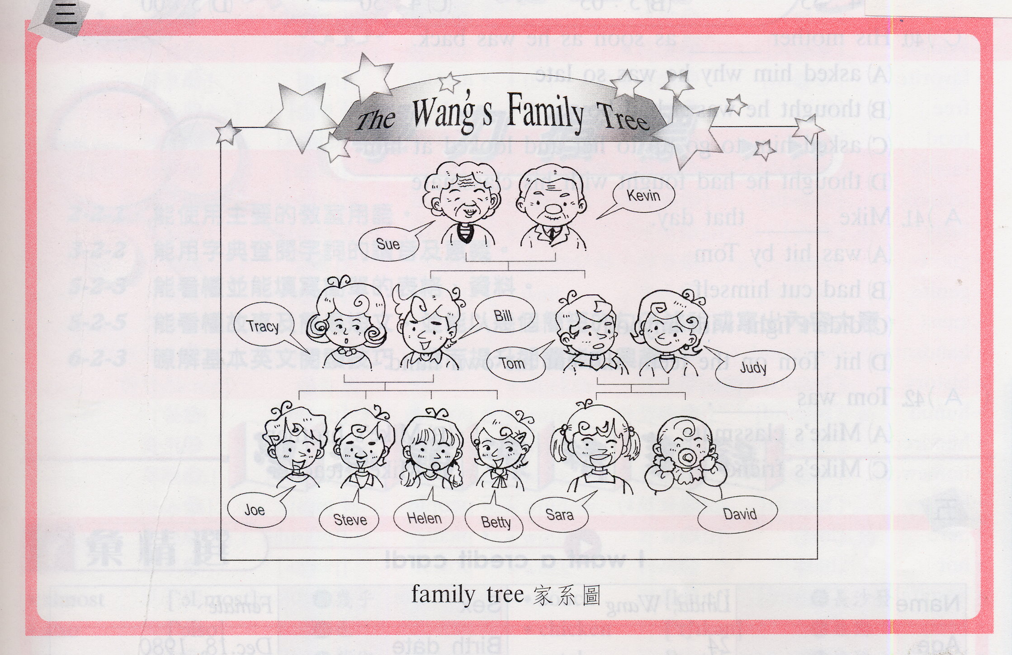
17.（ ）(A) Kevin is Sue’s father.
(B) Betty and Judy are sisters.
(C) Tracy and Bill have four children.
(D) Bill and Tracy are Sue and Kevin’s children.
18.（ ）How many granddaughters and grandsons do Kevin and Sue have?
(A) five (B) six (C) seven (D) eight
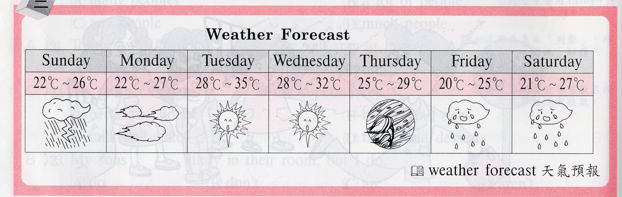
19.（ ）How is the weather on Wednesday?
(A) It’s cloudy. (B) It’s sunny. (C) It’s rainy. (D) It’s snowy.
20.（ ）We should bring umbrellas with us on .
(A) Monday and Tuesday. (B) Friday and Monday.
(C) Friday and Saturday. (D) Saturday and Wednesday.

祝 各位同學考試愉快！

背面尚有試題

財團法人雲林縣永年高級中學文教基金會
96年度國小學藝競試 英文科答案

41.D | 42.D | 43.A | 44.D | 45.B
46.C | 47.C | 48.B | 49.C | 50.A
51.A | 52.D | 53.D | 54.A | 55.C
56.A | 57.C | 58.B | 59.B | 60.C

